Engagement Action Plan 2026
Company-wide and department actions after the June survey
Julia Hoffmann · 29 September 2026
This plan collects the actions agreed in the team workshops held between July and September 2026. Department heads own their actions; HR tracks progress monthly.
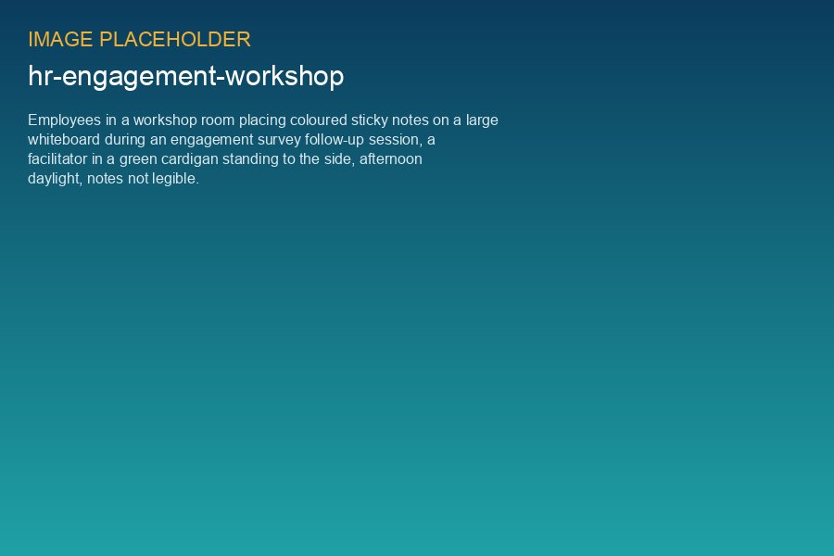
Workshop with the Asset Operations team in Edinburgh, 26 August 2026

Company-wide
# | Action | Owner | Due | Status
1 | Technician career path T1–T4 with transparent pay steps | Julia Hoffmann, David Chen | 2026-12-15 | In progress
2 | Meeting-free Friday mornings | Executive Board | 2026-09-01 | Done
3 | Cross-office project days (Hamburg/Edinburgh/Copenhagen) | Julia Hoffmann | 2026-11-20 | Planned
4 | Manager training 'Leading under pressure' | Julia Hoffmann | 2026-11-30 | Booked

Department actions (selection)
Department | Finding | Action | Status
Projects (Harrow Bay) | Workload 41 % favourable | +4 FTE approved, rota for weekend shifts | Hiring
Asset Operations | Growth 58 % | Technician path + GWO advanced rescue for all | In progress
Legal & Contracts | Workload 47 % | Paralegal support from external pool during PPA/claims peaks | Done
Engineering | Collaboration 63 % | Monthly engineering review across offices | Done
IT & Security | Recognition 59 % | Quarterly 'quiet heroes' shout-out in town hall | Done

Next pulse survey: January 2027 (10 questions, 5 minutes).

